NOW AVAILABLE:
Online Registration and Payment

As a convenience to customers, the Cumberland Valley SD now provides an easy way to register and pay for aquatics programs. Customers may pay with Discover, VISA, or MasterCard credit or debit cards for these items. Our Web Store accepts payments over the internet 24/7. By contracting with RevTrak, a national credit card payment processor, we provide you a secure site for making payments.

Pay the following fees online:
- Baby Eagles (Summer Sessions)
- Swim School (Summer Sessions)

Customers can register and make payments online while on their home or work computer, any time of the day. It only takes a few minutes to make a payment using a Discover, VISA, or MasterCard credit or debit card. The convenience of paying online is further enhanced when customers access the store and see a familiar shopping cart (just like shopping online).

To make an online payment follow these simple steps:

- Visit our Web Store at http://cumberland.revtrak.net
- Click on the Aquatics Button
- Make payment using a Discover, VISA, or MasterCard debit or credit card

Please visit the Cumberland Valley SD website for future updates!
Cumberland Valley School District
6746 Carlisle Pike
Mechanicsburg, PA 17050
http://www.cvschools.org/

See reverse side for detailed payment instructions.

Instructions for Making a Payment

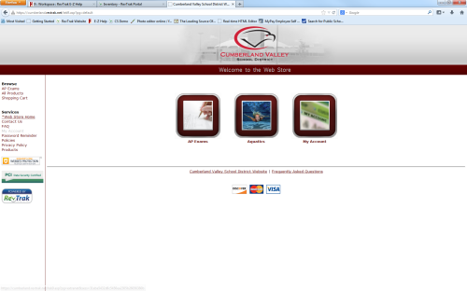
- Go to the Web Store at http://cumberland.revtrak.net

- Click on the Aquatics button on the home page

- Choose the class you would like to sign up for

- Click on the Class Number

- Select the Click Here to Register link

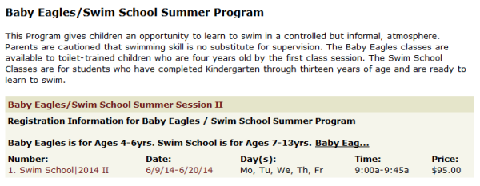
- You will now be taken to a page that allows you to create an account or use an email address and password to login to a current account

- After creating or logging into an account, add your child as a participant

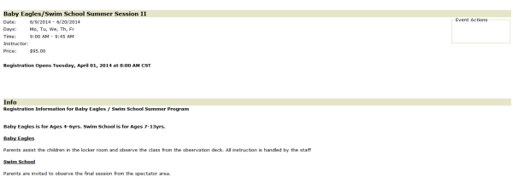
- Answer the required questions and/or enter the required information

- Clicking on either Continue Shopping or Go to Checkout at the bottom of the page will add your class to the shopping cart

- When all classes are in your shopping cart, click Go to Checkout

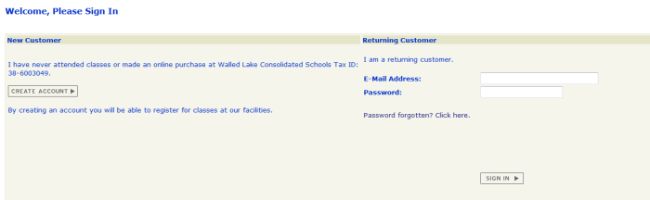
- If you are a new customer select “I am a new customer” and enter your email address (you will create a password later). If you are a returning customer select “I am a returning customer” and enter your email address and password. Select Sign In.

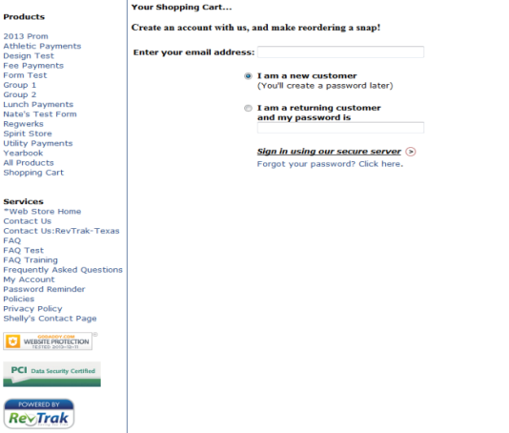
- Enter your Billing Information, Payment Information, and create a password

- Verify information for accuracy and select “Complete Order”

- Payment will be processed and Receipt can be viewed and printed

- Logout

